CLIENT-SIDE PERSONAL FINANCE MANAGEMENT (PFM) WEB APPLICATION
A Frontend Development Project Report

Submitted by
Vishwa Teja (2501050050)
SivaGanesh EDE (2501050016)

In partial fulfilment of the requirements for the course
Frontend Development

Submitted to
Department of Computer Science and Engineering
KL UNIVERSITY
(DEEMED TO THE UNIVERSITY)

Under the guidance of
Chaitanya Krishna B

Academic Dean

Academic Year 2024–2025
Department of Computer Science & Engineering K L E F,
Green Fields, Vaddeswaram- 522502 Guntur (Dist), Andhra Pradesh, India

DECLARATION

The Project Report entitled “Client-side Personal Finance Management” is a record of Bonafide work of VISHWA TEJA S(2501050050) submitted in partial fulfillment for the award of M Tech in Computer science and engineering to the KL University. The results embodied in this report have not been copied from any other departments/University/Institute.

Name of the Student Signature of the Student

VISHWA TEJA S (2501050124)

CERTIFICATE
This is to certify that the Project Report entitled “Client-side Personal Finance Management” is being submitted by VISHWA TEJA S (2501050050) submitted in partial fulfillment for the award of M Tech in Computer Science and Engineering at K L University. The results embodied in this report have not been copied from any other departments/University/Institute.

The results embodied in this report have not been copied from any other departments/ University/Institute.

Signature of the Guide
Chaitanya Krishna B,
Academic Dean,
Department of CSE.

ABSTRACT
This project presents a client-side Personal Finance Management (PFM) web application aimed at helping students and young adults improve financial discipline. Many individuals in this demographic struggle with irregular spending patterns and lack reliable tools to maintain budgets effectively. The proposed system provides a fully browser-based platform built using HTML5, Vanilla JavaScript, and a utility-first CSS approach to deliver a clean, responsive, and user-friendly interface.
The application relies entirely on the browser’s local Storage API for data persistence, ensuring complete privacy and eliminating the need for any backend server or online connectivity. To enhance user understanding of financial trends, the system incorporates Chart.js, enabling clear visualisations of category-wise expenses and spending patterns.
The outcome is a lightweight, offline-capable, and privacy-focused financial management tool that supports users in tracking expenses, analysing financial behaviour, and making informed budgeting decisions. This makes the solution highly suitable for students, first-time budgeters, and individuals seeking a simple yet effective personal finance tracker.

TABLE OF CONTENTS

CHAPTER | TITLE | PAGE NO.
 | ABSTRACT | v
1 | INTRODUCTION | 1
 | 1.1 BACKGROUND OF THE CHOSEN PROBLEM | 1
 | 1.2 IMPORTANCE OF THE SYSTEM | 2
 | 1.3 NEED FOR THE PROJECT | 3
 | 1.4 TARGET USERS | 4
2 | PROBLEM DEFINITION | 5
 | 2.1 CURRENT ISSUES | 5
 | 2.2 PAIN POINTS IDENTIFIED | 6
 | 2.3 PURPOSE OF SOLVING THE PROBLEM | 6
3 | OBJECTIVES OF THE PROJECT | 7
4 | SCOPE OF THE PROJECT | 9
 | 4.1 FEATURES INCLUDED | 9
 | 4.2 FEATURES EXCLUDED (OPTIONAL) | 10
 | 4.3 USER ROLES | 10
5 | LITERATURE SURVEY / EXISTING SYSTEMS | 11
 | 5.1 STUDY OF EXISTING APPLICATIONS | 11
 | 5.2 LIMITATIONS OF EXISTING SYSTEMS | 12
 | 5.3 DIFFERENCE OF PROPOSED SYSTEM | 13
6 | SYSTEM REQUIREMENTS | 14
 | 6.1 SOFTWARE REQUIREMENTS | 14
 | 6.2 HARDWARE REQUIREMENTS | 15
7 | SYSTEM DESIGN | 16
 | 7.1 ARCHITECTURE DIAGRAM | 16
 | 7.2 USE CASE DIAGRAM | 17
 | 7.3 ACTIVITY DIAGRAM | 18
 | 7.4 SEQUENCE DIAGRAM | 19
 | 7.5 UI WIREFRAMES | 20
8 | RESULTS | 27
 | 10.1 WORKING SCREENSHOTS | 27
 | 10.2 PERFORMANCE RESULTS | 28
 | 10.3 FEATURE DEMONSTRATION | 29
9 | CONCLUSION | 30
10 | FUTURE ENHANCEMENTS | 31
11 | REFERENCES | 32

CHAPTER 1
INTRODUCTION

1.1 Background of the Chosen Problem
Managing personal finances has become a crucial life skill, especially for students and young adults who are transitioning into financial independence. Many individuals in this demographic rely on irregular sources of income such as pocket money, part-time jobs, or educational allowances, making it difficult to maintain a stable financial routine. Despite growing awareness about financial literacy, most students lack structured tools or systems that help them keep track of their spending. Traditional methods such as manual entries in notebooks or basic spreadsheets often fail to provide meaningful insights or long-term tracking capabilities. Additionally, the existing digital solutions available in the market tend to be complex, require online connectivity, or demand users to share sensitive information, making them unsuitable for beginners who prefer simplicity and privacy. This growing gap between financial needs and available solutions forms the foundation for choosing this problem domain.
1.2 Importance of the System
A dedicated Personal Finance Management (PFM) system plays an essential role in helping users gain clarity over their financial behaviour. This system enables users to record daily expenses, maintain budget limits, and analyze spending patterns through visual summaries. Financial awareness at an early stage fosters responsible decision-making and encourages long-term discipline. Providing users with an intuitive and user-friendly platform ensures that even non-technical individuals can manage their finances effectively without feeling overwhelmed. A modern finance tool should not only allow users to store expense details but also offer real-time calculations, category-based analysis, and visually rich representations of financial trends that support better judgment. Therefore, the system becomes significantly important in bridging the gap between financial knowledge and practical financial control, empowering users to take proactive steps toward financial stability.
1.3 Need for the Project
The need for this project arises from the limitations of existing financial management tools, particularly for first-time budgeters. Many available finance applications require account creation, cloud storage, or access to personal data, which raises concerns about privacy and data security. Some platforms are feature-heavy and designed for professional use, which may discourage beginners from adopting them due to their complexity. Students and young adults need a system that is easy to use, visually intuitive, and does not rely on backend servers or internet connectivity. A fully client-side solution using local Storage ensures that all data remains within the user’s device, providing complete privacy and offline functionality. Additionally, integrating interactive charts and automated summaries enhances understanding and motivates consistent usage. This project directly addresses these needs by offering a lightweight, secure, and accessible personal finance tool tailored to the habits and requirements of young users.

1.4 Target Users
The primary target users of this Personal Finance Management system are students, college-goers, and young adults who are beginning to manage their own finances. These users typically have limited financial experience and require a simple tool to build healthy budgeting habits. Additionally, individuals who prefer privacy-focused tools that do not require online login or data sharing can greatly benefit from this system. Users who have irregular income sources, such as part-time workers or freelancers, can use the system to gain clarity over their earnings and spending patterns. The system is also suitable for anyone seeking a straightforward, visually appealing, and offline-capable financial tracking application. By targeting these user groups, the project ensures relevance, accessibility, and practical value in real-world scenarios.

CHAPTER 2
PROBLEM DEFINITION
2.1 Current Issues
Students and young adults often face significant challenges in managing their personal finances due to irregular income sources, inconsistent spending patterns, and a lack of practical knowledge regarding budgeting. Many individuals still rely on manual methods such as diaries, notebooks, or spreadsheets to record expenses, but these methods are time-consuming, prone to human error, and incapable of offering analytical insights. Additionally, existing financial management applications available in the market often require users to create accounts, link bank details, or store sensitive financial data on cloud-based servers, raising concerns about privacy and security. These applications also tend to be complex and designed for advanced users, making them unsuitable for beginners who need a minimal and straightforward system. The absence of a simple, private, and offline-capable finance tool becomes a major barrier for users attempting to improve their financial discipline.
2.2 Pain Points Identified
A key problem faced by most new budgeters is the inability to visualize where their money is being spent. Without clear visual interpretation, users fail to recognize financial patterns, identify unnecessary expenditures, or adjust their habits accordingly. Another major pain point is the lack of real-time updates; traditional methods that require manual recalculation hinder accurate monitoring of remaining budgets. Existing mobile and web applications introduce additional difficulties such as mandatory sign-ups, intrusive permissions, non-transparent data handling, and steep learning curves. Users who prioritize privacy often avoid these tools altogether, leaving them without any efficient method for tracking daily expenses. Furthermore, applications that depend on online connectivity are impractical for users with restricted internet access or those who prefer lightweight, dependency-free tools. These pain points collectively highlight the need for a system that prioritizes simplicity, accessibility, privacy, and user-friendliness.
2.3 Purpose of Solving the Problem
The primary purpose of solving this problem is to provide a reliable and intuitive platform that helps users build financial awareness and develop consistent budgeting habits. By offering a fully client-side web application that stores data locally using the browser’s local Storage API, users can track expenses securely without worrying about data breaches or account creation. The system aims to automate calculations, simplify financial monitoring, and present meaningful visualizations through charts and summaries, ensuring that users can easily interpret their spending behaviour. A minimalistic and responsive interface further ensures that the tool is accessible to all users, regardless of their technical expertise. Ultimately, this project seeks to empower students and young adults to make informed decisions, avoid overspending, and cultivate long-term financial discipline through a system that is both practical and privacy-focused.

CHAPTER 3
OBJECTIVES
The primary objective of this Personal Finance Management (PFM) web application is to provide a simple, intuitive, and efficient system for tracking personal finances. The project aims to create a fully client-side application using HTML5, Vanilla JavaScript, and utility-first CSS, allowing users to monitor income, track daily expenses, and analyze financial behavior without relying on backend servers or external storage.
A key objective is to implement real-time financial calculations, enabling users to instantly view total expenses, remaining balance, and overall budget status. Full CRUD (Create, Read, Update, Delete) functionality ensures users can manage transactions easily through a user-friendly interface.
The project also focuses on analytical insights to support informed decision-making. By integrating Chart.js, the system visualizes spending patterns, category-wise expenses, and overall financial trends. Automated summaries, including total transactions, average expenses, and category distribution, help users evaluate their financial health effectively.
Privacy and data security are central objectives. All data is stored locally using the browser’s localStorage API, eliminating the need for online accounts or cloud services. Utilities such as data backup, export to CSV/PDF, and restore options ensure safe and convenient data management.
In summary, the project aims to deliver a lightweight, secure, and feature-rich personal finance tool that promotes financial awareness, supports responsible budgeting, and helps users control overspending through an interactive and analytical interface.
The project aims to achieve the following:
- To develop an intuitive, responsive, and interactive frontend interface for managing personal finances.
- To implement a real-time dashboard showing Budget, Total Expenses, and Remaining Balance.
- To provide CRUD functionality for adding, editing, and deleting expense transactions.
- To enable data visualization using Chart.js for category-wise and monthly spending patterns.
- To persist user data using browser-based localStorage, ensuring offline operation and privacy.
- To generate automated insights and summaries to guide financial decisions.
- To support export, backup, and restore options for data portability and user convenience.

CHAPTER 4
SCOPE OF THE PROJECT
The scope of this Personal Finance Management (PFM) web application includes developing a complete, client-side financial tracking system to help users monitor daily expenses, manage budgets, and analyse spending behaviour. The project focuses on creating a lightweight and user-friendly platform that works entirely within a web browser using HTML5, CSS, and Vanilla JavaScript. By relying exclusively on client-side technologies, the system ensures broad accessibility across devices and provides users with a simple and efficient method for managing their finances without requiring advanced technical skills.
Within its scope, the application offers essential features such as adding, editing, deleting, and viewing financial transactions. It supports budget setting, real-time calculation of expenses, and continuous balance updates, enabling users to maintain a clear and accurate overview of their financial status. The system also organises expenses by category and timestamp, allowing users to maintain a structured and detailed record of their spending habits.
A key part of the project’s scope includes providing visual insights through interactive charts generated using Chart.js. These visualisations, including category-wise breakdowns and monthly spending patterns, help users easily interpret financial trends and make informed decisions. The system also incorporates local Storage-based data management, ensuring that all financial information is stored securely on the user’s device, enabling offline access and guaranteeing full data privacy.
The scope also includes utilities such as data backup, restore, and export options, allowing users to save their financial records in JSON, CSV, or PDF format. These features enhance portability and ensure that users can maintain their data independently.
However, the project does not include features such as cloud synchronisation, multi-user authentication, real-time bank integration, or server-side processing, as these require backend infrastructure beyond the intended client-side architecture. By defining these boundaries, the project maintains its focus on simplicity, privacy, and ease of use.

CHAPTER 5
LITERATURE SURVEY / EXISTING SYSTEMS
5.1 Introduction
Personal Finance Management (PFM) applications have gained widespread adoption as individuals seek effective tools to track expenses, manage budgets, and improve financial discipline. Several commercial and open-source applications provide expense tracking, budgeting assistance, and financial visualization features. However, these systems often exhibit limitations related to privacy, usability, offline accessibility, and complexity. This chapter presents a study of three similar applications—Walnut, Goodbudget, and Money Manager—to analyze their features and limitations, and to highlight how the proposed Personal Finance Management web application addresses the identified gaps.
5.2 Existing System 1: Walnut (Expense Manager)
Walnut is an automated expense management application primarily designed for mobile platforms. The application automatically detects transactions by reading SMS messages related to bank transactions and digital payments. It categorizes expenses, generates monthly spending reports, and provides visual charts that help users understand their spending behaviour. Walnut also supports reminders for bill payments and allows users to export financial data for external use.
Despite its automation advantages, Walnut has notable limitations. The application requires permission to read SMS messages, which raises privacy and security concerns, especially for users handling sensitive financial information. It also relies on continuous internet connectivity for synchronization and analytics features. Additionally, automatic categorization may sometimes be inaccurate, and users have limited control over correcting or customizing transaction categories.
In contrast, the proposed system eliminates the need for SMS access or internet connectivity. All financial data is entered manually and stored locally in the browser using localStorage, ensuring complete privacy and transparency. The system provides users full control over categories and transactions, making it more suitable for privacy-conscious users and students.
5.3 Existing System 2: Goodbudget (Envelope Budgeting Application)
Goodbudget is a budgeting application based on the envelope budgeting methodology. Users allocate their income into different digital envelopes representing spending categories. The application supports cross-device synchronization, spending reports, and long-term budgeting analysis. It helps users plan expenses in advance and encourages disciplined spending through predefined category limits.
However, Goodbudget depends on cloud-based services and requires account creation, which may not appeal to users who prefer offline or anonymous usage. The free version restricts the number of envelopes and devices, limiting functionality for new users. Moreover, the envelope method may feel rigid and inconvenient for users with irregular income or unpredictable expenses.
The proposed Personal Finance Management web application offers a more flexible approach to budgeting. It does not enforce a specific budgeting model, allowing users to track expenses freely based on their individual spending patterns. The system works entirely offline without account registration, making it simpler, more accessible, and privacy-focused.
5.4 Existing System 3: Money Manager (Realbyte)
Money Manager is a feature-rich financial management application that provides detailed expense tracking, asset management, budget planning, and visual analytics. The application includes calendar-based transaction tracking, graphical reports, password protection, and data export options. These features make it suitable for users who require advanced financial monitoring.
Despite its comprehensive functionality, Money Manager can be overwhelming for beginners due to its complex interface and extensive financial terminology. Many advanced features are available only in the paid version, which limits access for students. Additionally, the application is primarily mobile-based and does not provide a fully client-side web solution.
The proposed system focuses on simplicity and ease of use by offering only essential features needed for effective personal finance tracking. It is entirely web-based and platform-independent, making it accessible on any device with a browser. Unlike Money Manager, all features are available without subscription or premium restrictions.
5.5 Comparative Summary
The analysis of existing systems reveals that while current applications provide useful financial management features, they often compromise on privacy, simplicity, or accessibility. Many rely on cloud services, paid subscriptions, or complex interfaces that are unsuitable for beginners. The proposed Personal Finance Management web application addresses these limitations by providing a lightweight, fully client-side, offline-capable, and privacy-preserving solution. By focusing on clarity, user control, and ease of use, the system offers a practical alternative for students and young adults seeking to develop better financial habits.

CHAPTER 6

SYSTEM REQUIREMENTS

A. Software Requirements
- HTML5, CSS3
- JavaScript
- Framework/Libraries (React, Vue, Angular, Bootstrap, Tailwind etc.)
- API / Backend services (if used)

B. Hardware Requirements
- Laptop/PC
- Browser
- VS Code or any IDE

CHAPTER 7

SYSTEM DESIGN

7.1 ARCHITECTURE DIAGRAM
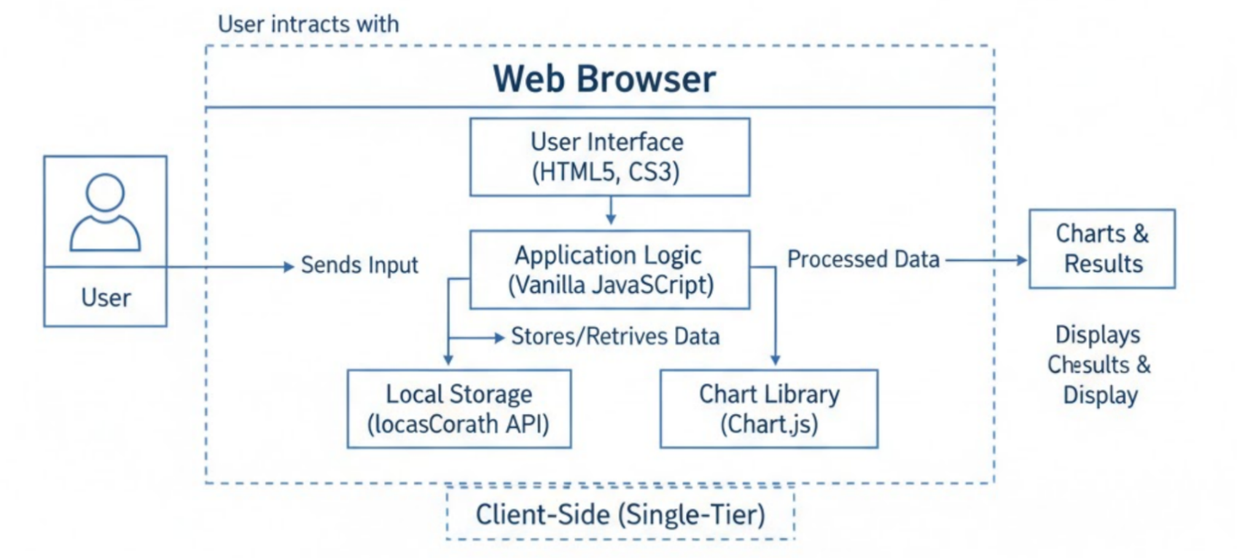

7.2 USE CASE DIAGRAM

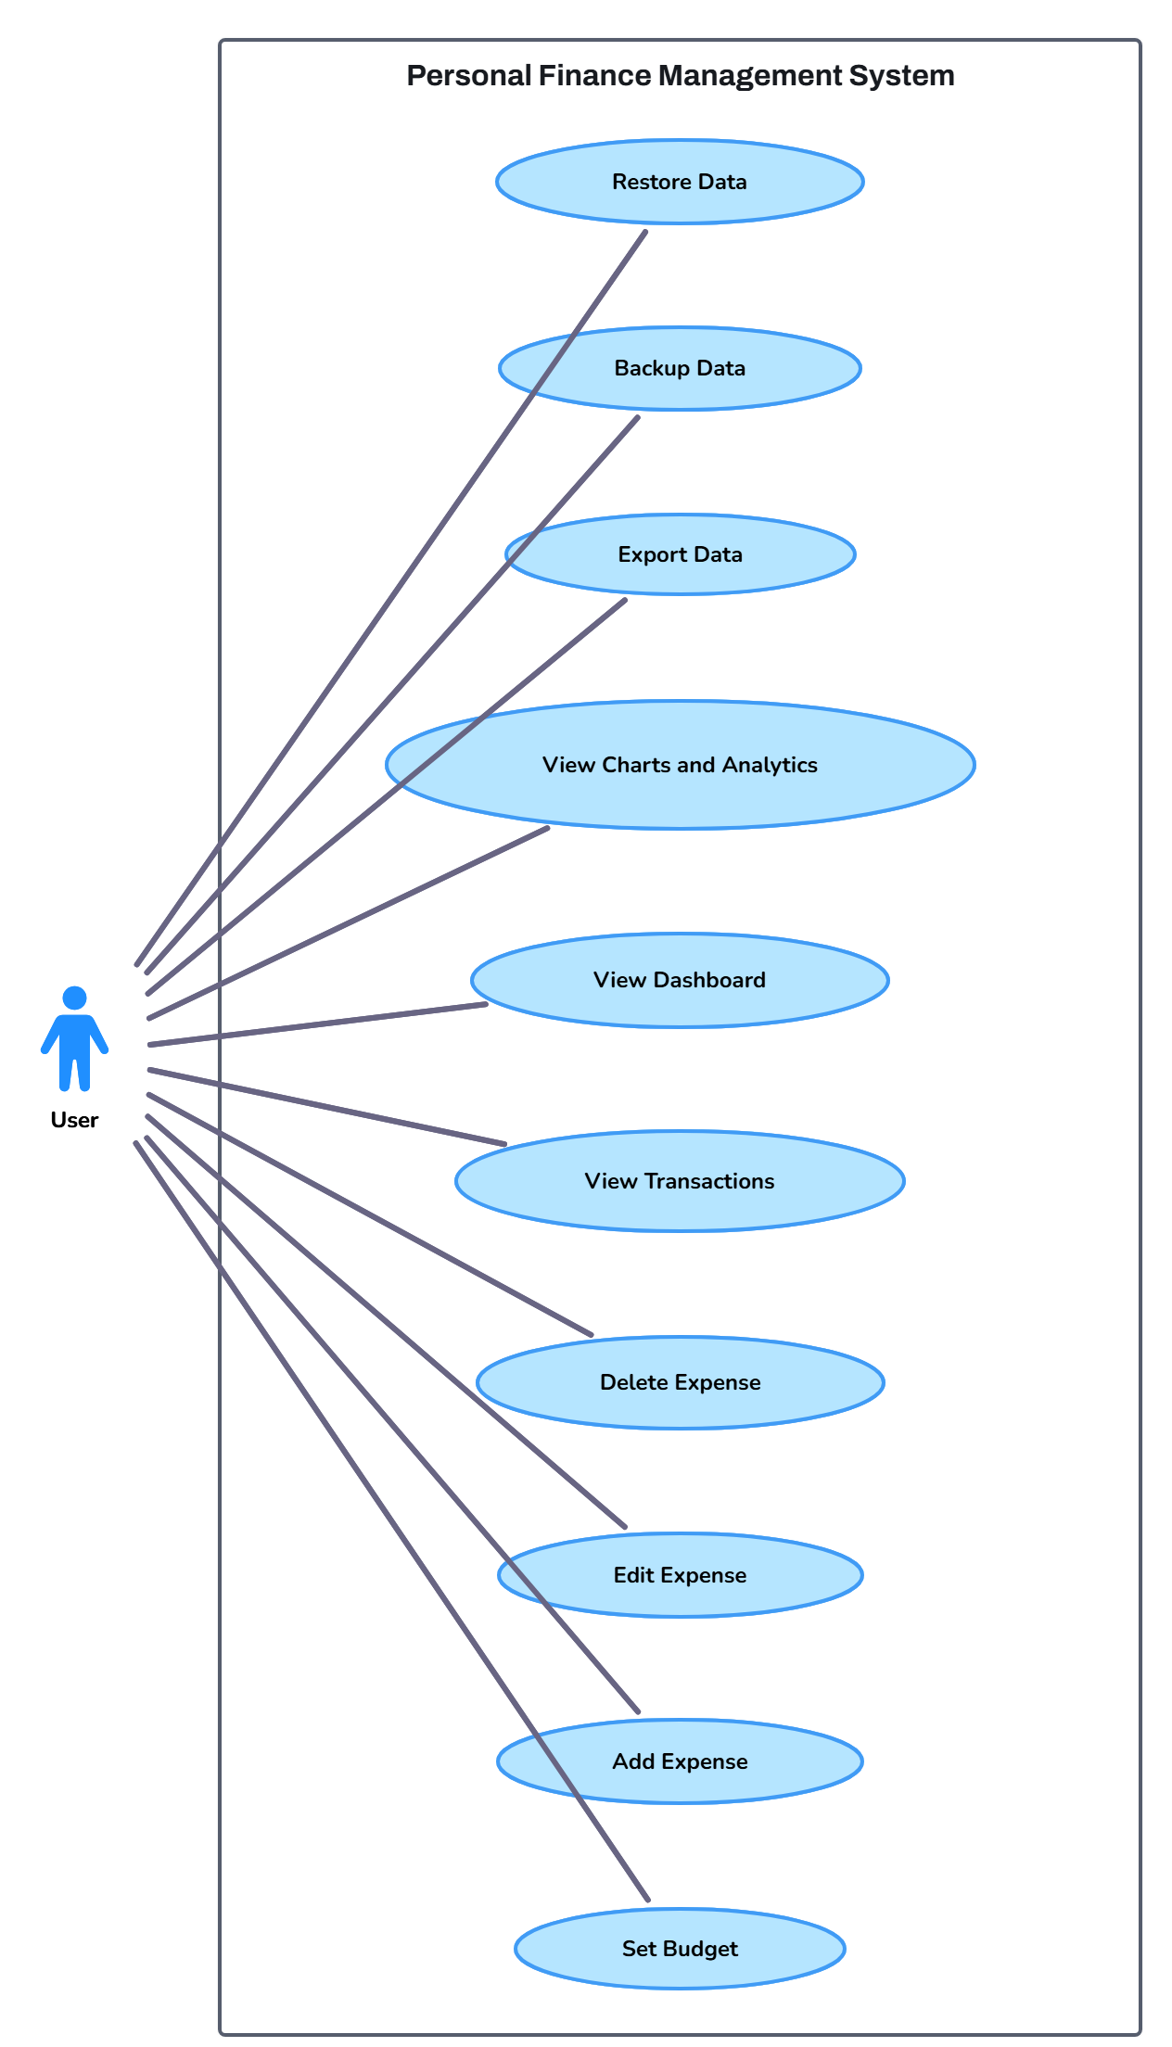

7.3 ACTIVITY DIAGRAM

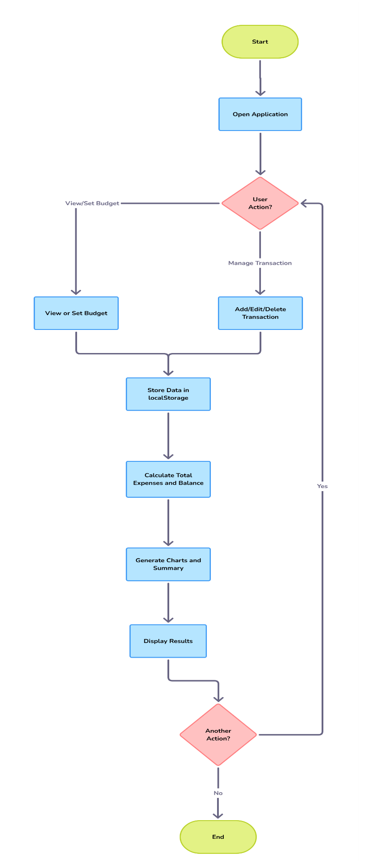

CHAPTER 10

TESTING

10.1 Introduction

Testing is a crucial phase in the software development life cycle that ensures the developed application functions correctly and meets the specified requirements. The primary objective of testing is to detect errors, verify functionality, and validate that the system behaves as expected under normal usage conditions.

For the Client-Side Personal Finance Management (PFM) Web Application, testing focuses on validating frontend functionality such as expense entry, budget calculation, data storage using localStorage, chart visualization, and user interface responsiveness. Since the system is completely client-side, emphasis is placed on functional testing, validation testing, and usability testing.

10.2 Objectives of Testing

The objectives of testing in this project are:
- To verify that all functional requirements are correctly implemented
- To ensure accurate calculation of expenses, balance, and budget
- To validate proper storage and retrieval of data using localStorage
- To check correct rendering of charts and analytics
- To ensure smooth navigation and user interaction
- To confirm that the system works without errors under normal usage

10.3 Testing Strategy

The testing strategy adopted for this project is manual testing, as the application is frontend-based and small in scale. Each module is tested independently, followed by integrated testing of the complete system.

The testing strategy includes:
- Unit Testing
- Integration Testing
- System Testing
- User Acceptance Testing

This approach ensures reliable verification of both individual components and the overall system.

10.4 Types of Testing Performed

10.4.1 Unit Testing

Unit testing focuses on testing individual modules of the application to ensure that each function works as intended.

Modules Tested:
- Add Expense Module
- Edit and Delete Transaction Module
- Budget Calculation Module
- localStorage Data Handling
- Chart Rendering Module

Each module was tested using valid and invalid inputs to verify correct behavior.

10.4.2 Integration Testing

Integration testing verifies the interaction between different modules after unit testing.

Examples:
- Expense form submission with dashboard updates
- localStorage data updates reflected in charts
- Budget updates reflected in remaining balance

This ensures smooth data flow between interconnected components.

10.4.3 System Testing

System testing validates the complete application as a whole.

System-level checks include:
- End-to-end expense tracking workflow
- Accurate dashboard summary display
- Proper analytics and chart updates
- Stability during repeated operations

The system performed correctly under all tested scenarios.

10.4.4 User Acceptance Testing (UAT)

User Acceptance Testing was conducted by allowing sample users (students) to interact with the system.

The system is considered acceptable if:
- Users can add and manage expenses easily
- Navigation is simple and intuitive
- Charts and summaries are clearly understandable

Feedback indicated high usability and clarity.

10.5 Test Environment

The testing environment used for this project is as follows:
Component | Specification
Operating System | Windows 10 / Windows 11
Web Browser | Google Chrome, Mozilla Firefox
Development Tool | Visual Studio Code
Hardware | Laptop/Desktop with minimum 4 GB RAM

This environment reflects typical real-world usage conditions.

10.6 Test Cases

Test Case Table (Friend-Style Academic Format)
Test Case ID | Test Description | Input | Expected Output | Actual Output | Status
TC-01 | Add new expense | Valid expense details | Expense added successfully | As expected | Pass
TC-02 | Submit empty form | No input | Error message displayed | As expected | Pass
TC-03 | Delete expense | Select expense | Expense removed | As expected | Pass
TC-04 | Edit expense | Modify values | Expense updated | As expected | Pass
TC-05 | Budget calculation | Multiple expenses | Correct remaining balance | As expected | Pass
TC-06 | Data persistence | Reload page | Data retained | As expected | Pass
TC-07 | Chart rendering | Expense data | Charts updated | As expected | Pass

CHAPTER 8

RESULT
8.1 LOGIN PAGE
The Login Page allows users to securely access the application using email and password, with validation and a demo login option for quick access.
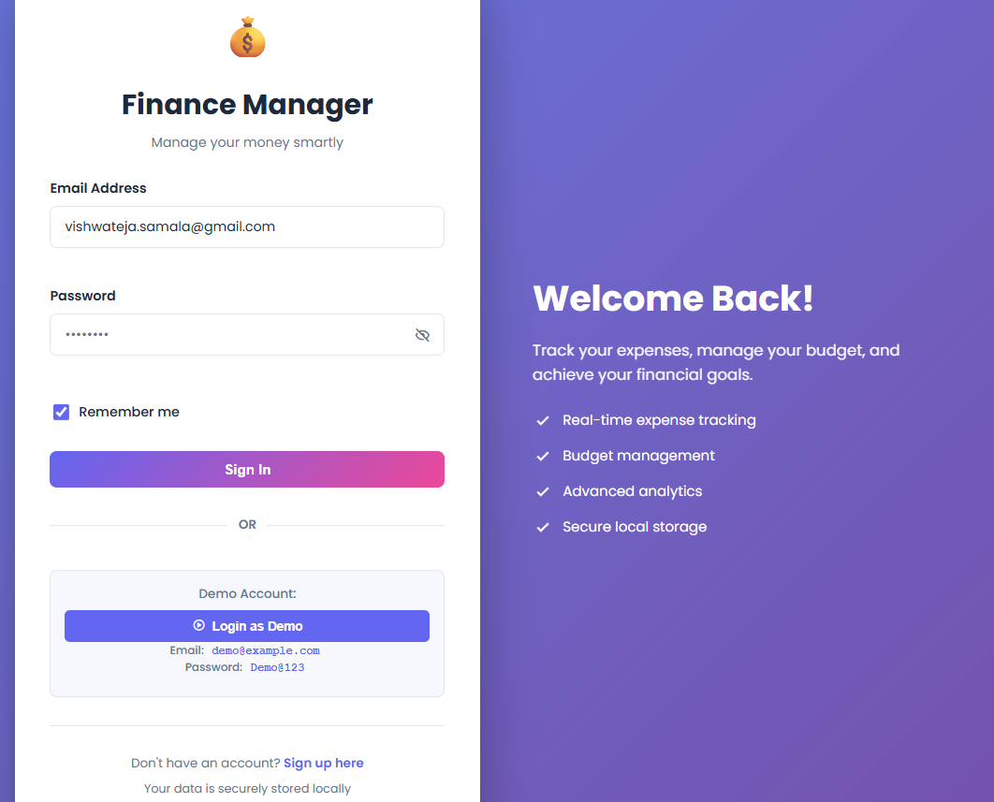

8.2 PROFILE PAGE
The Profile Page displays user details such as name, email, account status, and quick financial statistics, allowing users to view and manage their profile information.
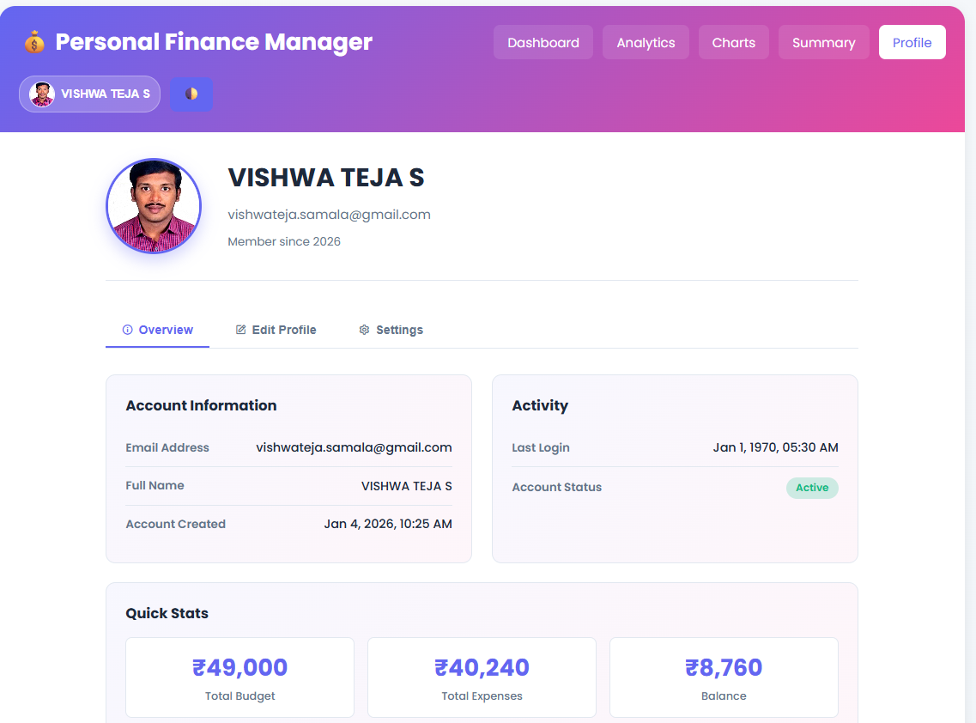

8.3 DASHBOARD PAGE
The Dashboard provides an overview of budget, total expenses, and remaining balance, along with options to add, edit, and delete expense transactions in real time.
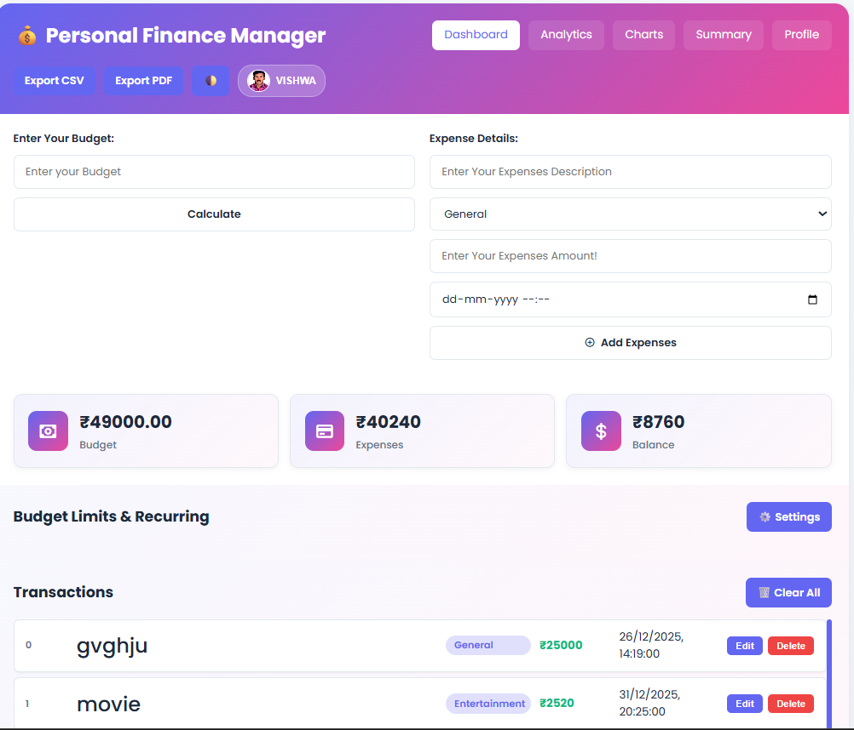

8.4 ANALYTICS PAGE
The Analytics Page offers detailed financial insights through filters, category-wise breakdowns, and key metrics such as most expensive category and balance status.
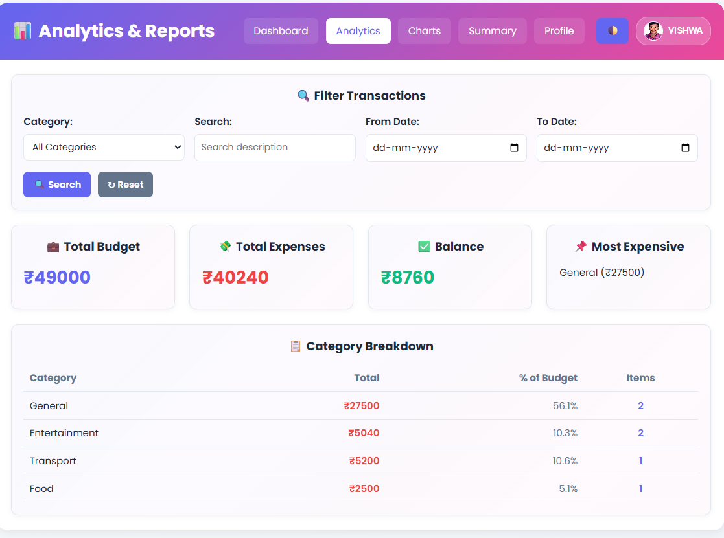

8.5 CHARTS PAGE
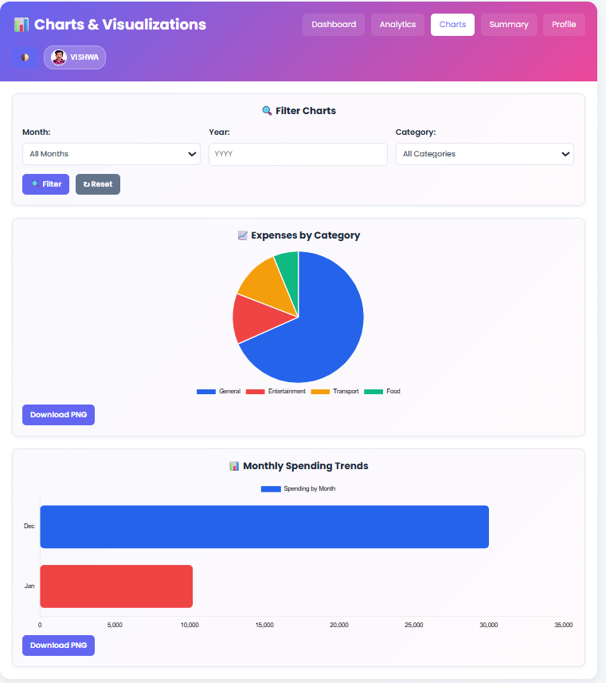
The Charts Page visually represents spending patterns using pie and bar charts, helping users analyze expenses by category and month effectively.

8.6 SUMMARY PAGE
The Summary Page presents a consolidated financial overview including total budget, expenses, balance, spending rate, and transaction analysis for quick decision-making.
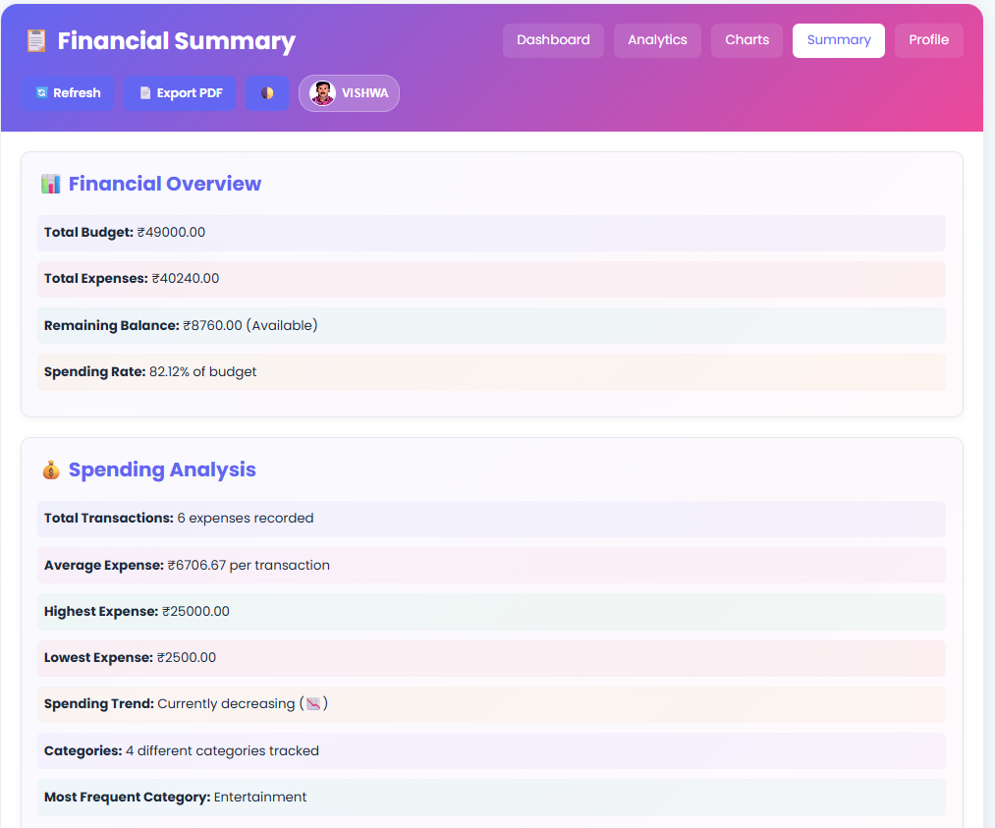

CHAPTER 9

CONCLUSION

9.1 Summary of the Outcome

The Client-Side Personal Finance Management (PFM) web application has been successfully developed as a lightweight, privacy-focused, and fully client-side tool. It allows users to record, edit, and delete transactions, track budgets in real-time, and visualize spending patterns with interactive charts. The system works offline using browser localStorage, ensuring data privacy and ease of use for students and young adults.

9.2 Student’s Learning

This project enhanced skills in HTML5, CSS, and Vanilla JavaScript, including DOM manipulation, data handling with localStorage, and creating visualizations with Chart.js. It also provided experience in designing user-friendly interfaces and managing an end-to-end web application project.

9.3 Success of the Project

The project met its objectives by delivering a functional, intuitive, and secure PFM application. It effectively addresses the issues of irregular spending and lack of privacy in existing tools, providing a practical solution for its target users.

CHAPTER 10

FUTURE ENHANCEMENTS

While the current version of the Personal Finance Management (PFM) web application fulfills all core objectives, several enhancements can be implemented to further improve its functionality and usability. Future versions may include cloud synchronization to allow users to access data across multiple devices, user authentication for personalized accounts, and bank integration for automatic transaction imports. Advanced analytics such as AI-based spending predictions, smart budget recommendations, and expense alerts can provide deeper financial insights. Additional features like mobile app support, multi-currency handling, and voice-based input can also enhance accessibility and user convenience. These improvements would make the system more powerful, intelligent, and adaptable to real-world financial management needs.

CHAPTER 11
REFERENCES
[1] A. Snow, R. Harper, and T. Heather, “Evaluating Budgeting Apps: Limited Support for Budgeting Compared to Tracking,” Lancaster University Research Publications, 2024. [Online]. Available: https://eprints.lancs.ac.uk/id/eprint/200745/1/Evaluating_Budgeting_Apps_Limited_Support_for_Budgeting_.pdf
[2] S. Snow, R. Harper, and L. Clarke, “Fixing the Alignment: An Exploration of Budgeting Practices in the Home,” Proc. CHI Conference on Human Factors in Computing Systems, pp. 437–446, 2015. [Online]. Available: https://dl.acm.org/doi/pdf/10.1145/2702613.2732808
[3] K. Lewis, D. Green, and P. Wong, “Follow the Money: Managing Personal Finance Digitally,” Proc. CHI, 2019. [Online]. Available: https://dl.acm.org/doi/fullHtml/10.1145/3290605.3300620
[4] N. Jayasekara and P. Sandanayake, “What People Like in Mobile Finance Apps: An Analysis of App Reviews,” Proc. 2nd Int. Conf. Hum.-Comput. Interact., 2018. [Online]. Available: https://dl.acm.org/doi/10.1145/3282894.3282895
[5] S. Angel and M. McGlynn, “Smart Tools? A Randomized Controlled Trial on the Impact of Budgeting Apps,” International Journal of Financial Studies, vol. 6, no. 4, pp. 89–101, 2018. [Online]. Available: https://www.sciencedirect.com/science/article/abs/pii/S2214804318301642
[6] V. Frisancho and A. Karlan, “Can a Mobile-App-Based Behavioral Intervention Teach Financial Habits? Evidence from a Randomized Trial,” Journal of Economic Behavior & Organization, 2023. [Online]. Available: https://www.sciencedirect.com/science/article/abs/pii/S0167268123002950
[7] T. Mahmoud, K. Wong, and J. Li, “A Decision-Support Tool to Bridge the Gaps in Financial Capability,” Proc. ACM Interactive Surfaces and Spaces (ISS), 2023. [Online]. Available: https://dl.acm.org/doi/10.1145/3544549.3583835
[8] R. Sharma, A. Chatterjee, and S. Singh, “UPI’s Impact on Spending Behaviour Among Indian Users,” Proc. ACM India HCI Conference, 2024. [Online]. Available: https://dl.acm.org/doi/fullHtml/10.1145/3613905.3651050
[9] L. Xiao and J. Porto, “The Interplay of Skills, Digital Financial Literacy, Capability and Impulsivity,” Financial Planning Review, vol. 5, 2022. [Online]. Available: https://www.sciencedirect.com/science/article/pii/S2214845022000837
[10] S. Zhang, A. Patel, and G. Kumar, “How Consumers Budget,” Journal of Economic Behavior & Organization, 2023. [Online]. Available: https://www.sciencedirect.com/science/article/abs/pii/S0167268122003493
[11] M. Köhler, “Digital Financial Literacy and Savings Behaviour,” Financial Planning Review, 2025. [Online]. Available: https://www.sciencedirect.com/science/article/pii/S2214845025001401
[12] A. Noor and M. Patel, “Unlocking Financial Literacy with Machine Learning: A Critical Review,” Technology in Society, 2024. [Online]. Available: https://www.sciencedirect.com/science/article/pii/S0160791X24003452
[13] C. Evans and H. Bates, “Creating and Managing Transactions and Budgets: Analysis of Personal Budgeting Tools,” Interacting with Computers, vol. 37, no. 5, pp. 381–399, 2025. [Online]. Available: https://academic.oup.com/iwc/article/37/5/381/7760111
[14] P. Ananth and L. Reddy, “Developing the Capability of Digital Financial Literacy,” Heliyon, vol. 9, no. 11, 2023. [Online]. Available: https://www.sciencedirect.com/science/article/pii/S2405844023091697
[15] M. Lina and H. Sparks, “What Makes a Good App Description?” Proc. CHI, 2014. [Online]. Available: https://dl.acm.org/doi/10.1145/2677832.2677842
[16] D. Green and K. Jones, “Insights from Collaborative Financial Technologies,” ACM Computers in Human Behavior Reports, 2024. [Online]. Available: https://dl.acm.org/doi/full/10.1145/3706598.3713119
[17] S. Kumar and R. Chauhan, “Machine-Learning Based Financial Management Mobile Application,” International Conference on Education & Digital Technologies, 2022. [Online]. Available: https://files.eric.ed.gov/fulltext/ED654467.pdf
[18] T. Abraham and S. George, “Student Financial Literacy: A Consolidation Model,” Cogent Economics & Finance, 2025. [Online]. Available: https://www.tandfonline.com/doi/full/10.1080/2331186X.2025.2547032
[19] S. Angel and M. Carter, “A Randomized Study of App-Based Interventions on Financial Behaviour,” International Journal of Consumer Studies, vol. 43, 2024. [Online]. Available: https://www.sciencedirect.com/science/article/abs/pii/S2214804318301642
[20] K. Lewis, J. Adams, and M. Ito, “Practice-Centred Insights into Digital Personal Finance Management,” Proc. CHI, 2019. [Online]. Available: https://dl.acm.org/doi/fullHtml/10.1145/3290605.3300620

